The Lift and Drag on a NACA 0012 Airfoil

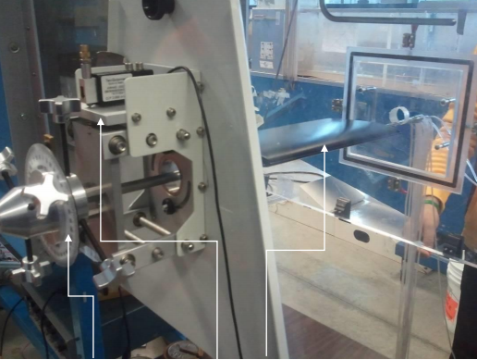

Charlie Nitschelm

April 14th, 2019

Contents

Table of Figures 2

Table of Tables 2

Abstract 3

Introduction 3

Experimental Methods 4

Results and Discussion 5

Summary and Conclusions 9

Appendix 10

Tables 10

MATLAB Code 11

# Table of Figures

Figure 1 - The effect of a NACA 0012 Airfoil angle of attack on the coefficent of lift and drag 6

Figure 2 - The effect of the NACA 0012 angle of attack on the ratio of the coefficient of lift and drag 7

Figure 3 - The amount of drag as a function of its angle of attack as calculated using manometer readings and fundamental equations plotted with actual, measured drag values for each angle of attack using a force balance 8

# Table of Tables

Table 1 - Data for figure one detailing the exact coefficients of lift and drag given the angle of attack on a NACA 0012 airfoil 10

Table 2 - The calculated induced drag on the airfoil given its angle of attack 10

Table 3 - The measured then calculated form drag on the airfoil given its angle of attack that has measurements 11

Table 4 - The calculated and measured values of drag from Figure 3 within the report at the various angles of attack of importance 11

# Abstract

Drag and lift are natural phenomenon that are studied to enhance our knowledge of flight. The goal of this research is to compare the measured drag and lift of a NACA 0012 airfoil within a wind tunnel with the measured sum of the integrated pressure distribution on the airfoil and estimated skin friction and induced drag. The measured drag and lift were done separately on a NACO 0012 3D printed airfoil in a wind tunnel at a constant speed, and the calculated drags were a combination of pressure data along the airfoil using manometers and skin and induced drag equations. Upon completion of the analysis, a clear relation between the methods used to predict the drag of the airfoil based on its conditions and angle of attach and the measured, actual values of the airfoil were clear, but with error. The maximum lift was seen at an angle of attack of 15 degrees, and a minimum drag was measured at an angle of attack of 0 degrees.

# Introduction

The lift and drag lab was meant to experiment with the comparison between lift and drag on a symmetrical, 3D printed airfoil within a controlled wind tunnel. The airfoil was equipped with a force balance that allowed the precise measurement of total drag and lift on the airfoil given its angle of attack to incoming airflow. It also had 20 pressure taps attached, both on the bottom and top of the airfoil to give us real-time manometer readings that could be converted to pressure to provide an analysis on the calculated drag to the real, measured drag. This was accomplished by integrating the pressure readings from the manometer to lift and drag forces, as well as use modern equations for skin drag and induced drag, all adding up to total calculated drag that could then be compared with the total measured drag from the force balance. The force balance was used to measure the drag and lift of the airfoil with angles of attack ranging from -9° to 21° in exactly 3° increments. The following equations were utilized to explicitly calculate the coefficients of lift and drag (, respectively) on the airfoil with the results of the airfoil providing total lift and drag for each angle of attack.

The following report will follow with the experimental methods used during the test, following the final analysis and results. Once the results have been clearly shown, a final conclusion was made towards the accuracy and final relations on the lift and drag induced on an airfoil when in a fluid flow field. Relevant data is also supplied within the appendix detailing specific and significant results on the findings within the lab.

# Experimental Methods

The NACA 0012 airfoil was attached within the test section of the UNH Mechanical Engineering wind tunnel. A force balance was equipped onto the attachment to get real-time lift and drag readings on the foil while the wind tunnel was on. 10 pressure taps were attached to the top of the airfoil in parallel with the fluid flow so actual pressure measurements could be obtained along the length of the foil. The same was done to the bottom so overall drag and lift forces could be calculated. The specific locations of the pressure taps were known and is attached at the end of this report in the appendix. When the wind tunnel was activated, it was set at a constant speed that could be calculated by using the following equation with all known variables on the right by having logically places manometers readings for the stagnation and static pressure on the airfoil providing the change in pressure along the airfoil,

The density of air,, was calculated using the classic ideal gas law with measured values of temperature and pressure within the room during the test, yielding . By having collected pressure measurements for three different angle of attacks, 0, 9, and 18°, 3 different calculated velocities could be calculated. The mean of these values were taken as the velocity of the flow, but the uncertainty of the calculation returns a more accurate calculation of 25.8 ± 0.2 m/s.

The manometer readings were then converted to pressure readings with the simple relation of fluid displacement vertically to the difference in pressure at the two ends:

Where these measurements were read in at angles of attack of 0, 9 and 18°. The force balance that was used to obtain measurements of lift and drag utilized a load cell at different configurations: oriented on the top of the balance to measure lift, and oriented on the side to measure drag force. The angle of attack of zero was found by tilting the balance to a degree so to zero the lift as the NACA 0012 is a symmetric airfoil. The force balance could then rotate and reach angles of 21° to study the effect on how drag and lift increase with these steep angles against the fluid flow.

The exact locations in the x-axis of the airfoil were given and are attached within the appendix, while the y component of its location is given by the equation



Where t is the maximum thickness of the airfoil as a fraction of the chord, and c is the chord length. With any location measurement, there is error ingrained into the number supplied, so exact manometer locations could vary with an uncertainity of at least ± 0.2 mm. Once the complete positions of the manometer reading were calculated, an analysis could be completed displaying the total force in the x-direction (drag) and the y-direction (lift). The following equations could be derived using the top and bottom geometry of the airfoil to calculate these forces:

*Top of the Airfoil Calculations:*

*Bottom of the Airfoil Calculations:*

Where is given by the equation below and takes in the airfoil geometry at each specific manometer location while integrating across the surface:

# Results and Discussion

The first step for the analysis of the data obtained from above is the velocity that the wind tunnel was suppling to the NACA 0012 airfoil, which was 25.8 m/s. The following calculation was to determine the coefficient of lift and drag for each angle of attack which can be found in Table 1 of the appendix and Figure 1 below. The actual force balance that was used to obtain the data for calculating the coefficient of lift and drag is accurate to the nearest 0.15 N, adding uncertainty to the overall system.

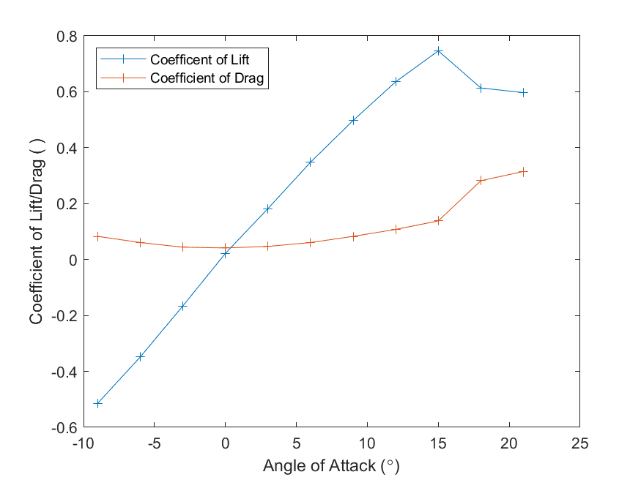

Figure - The effect of a NACA 0012 Airfoil angle of attack on the coefficent of lift and drag

From the figure above and observing the table of values in the appendix, it is clear that at 0 angle of attack, a non-zero lift value was recorded. A linear regression was calculated showing that an angle of attack of 0.26 was the value that recorded zero lift force, which is fundamentally wrong as the NACA 0012 airfoil is symmetrical and should show no lift force at exactly 0. This is assumed to be the cause of slight unsteady flow of the wind tunnel as well as a imperfect geometry that was 3D printed causing small error in the overall geometry, and therefore its symmetry. The figure above also shows that the maximum coefficient of lift was found to be at an angle of 15, with a slight drop off following it into 21. This maximum also correlates to the coefficient of drag, where it quickly rises as the coefficient of lift finds its maximum and decreases. The angles of attack past the maximum point described above is when an airfoil experiences ‘stall’, which means the angle where the coefficient begin to experience a negative slope until it reaches near-zero.

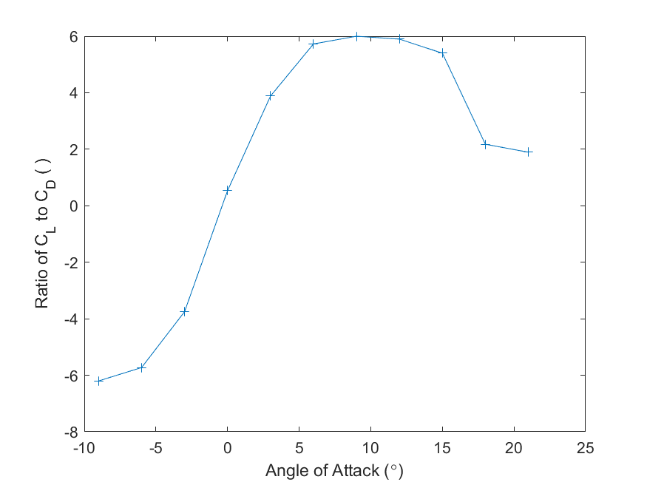

Figure - The effect of the NACA 0012 angle of attack on the ratio of the coefficient of lift and drag

Figure 2 above illustrates when the peak efficiency is met at a certain angle of attack the maximizes the lift force of the airfoil in relation to the drag force. The peak rises to nearly 6 at an angle of attack between 5-15 degrees, which matches the trend we saw within Figure 1. Once the calculations above were completed, the skin, induced and form drag could be numerically or analytically calculated depending on which type. The skin drag was assumed to be constant through every angle of attack so the following equations could be utilized to fit within the drag force equation:

Once the skin friction drag was calculated, the induced drag on the airfoil could be modeled using the fundamental equation for its coefficient of drag and the basic drag equation again above

where t is the span to chord ratio of the airfoil, and is the efficiency factor of the foil which was said to be 0.7. Plugging that into the fundamental drag equation yielded the drag associated to that type of force which can be found within the appendix in a table as well as Figure 3 below. The form drag of the foil was numerically integrated from the manometer readings, which was explained above, and plotted within Figure 4. Once the 3 major components of drag force were found, a total calculated drag force was obtained allowing for the comparison between the real drag data from the force balance and the calculated value numerically and analytically.

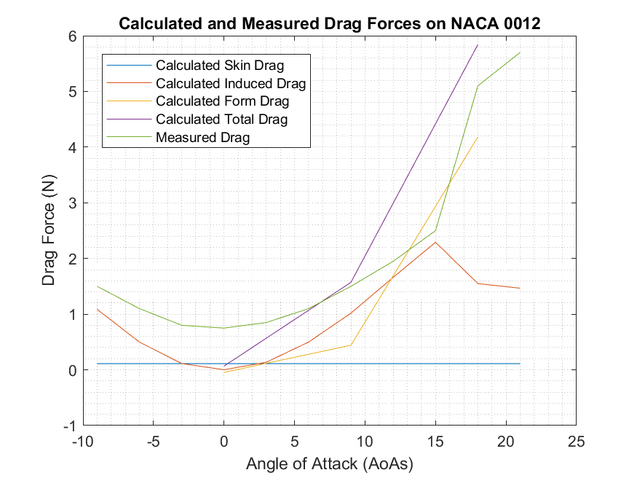

Figure - The amount of drag as a function of its angle of attack as calculated using manometer readings and fundamental equations plotted with actual, measured drag values for each angle of attack using a force balance

Figure 3 above details that although the green line, measured drag, and the purple line, calculated drag, are not the same, the numerical and analytical methods used to estimate these forces are on par with what was measured using a force balance, verifying that our methods, although not perfect, serve a relative purpose to helping us simulate the characteristics of an airfoil in flight before flying it.

Lastly, a total uncertainty of the coefficient of lift was calculated by summing up all the uncertainties of our measurements through the lab which included the force balance (0.1 N), the calculated area (.25 ), manometer readings (0.05 in H2O). and density calculations (0.05 kg/m3).

Where , are the uncertainties in the force balance, calculated area, manometer readings and the density calculation, respectively. The uncertainty in the coefficient of lift came out to be 0.008 which is nearly 1 percent of the max coefficient of lift from our data. Given the configuration, this uncertainty is acceptable and helps us believe the results found within this experiment.

# Summary and Conclusions

The NACA 0012 airfoil, which is a symmetric airfoil compared to its top plane and bottom plane geometry displayed very noticeable lift and drag characteristics after experimental testing. The most efficient range of angles of attack to operate at came out to be within the range of 5-15 degrees, which is right before a drop-off of the coefficient of lift and an influx within the coefficient of drag. This experiment also proved that current numerical methods in pressure integration along the airfoil and analytical equations derived from airfoil geometry provided a great prediction on how the airfoil would behave in respect to its drag force on its angle of attack in relation to the fluid flow provided from the wind tunnel. References

**[1]** “Stall (Fluid Dynamics).” *Wikipedia*, Wikimedia Foundation, 11 Apr. 2019, en.wikipedia.org/wiki/Stall_(fluid_dynamics).

**[2]** Figliola, R.S., and Donald E. Beasley. *Theory and Design for Mechanical Measurements*. John Wiley & Songs, 2015.

# Appendix

This appendix contains complementary information on the data presented and a detailed code printout on how this information was obtained and calculated.

## Tables

Table - Data for figure one detailing the exact coefficients of lift and drag given the angle of attack on a NACA 0012 airfoil

|  |  |  |
| --- | --- | --- |
| Angle of Attack (°) | Coefficient of Lift | Coefficient of Drag |
| -9 | -0.51 | 0.08 |
| -6 | -0.35 | 0.06 |
| -3 | -0.17 | 0.04 |
| 0 | 0.02 | 0.04 |
| 3 | 0.18 | 0.05 |
| 6 | 0.35 | 0.06 |
| 9 | 0.50 | 0.08 |
| 12 | 0.64 | 0.11 |
| 15 | 0.75 | 0.14 |
| 18 | 0.61 | 0.28 |
| 21 | 0.60 | 0.32 |

Table - The calculated induced drag on the airfoil given its angle of attack

|  |  |
| --- | --- |
| Angle of Attack (°) | Induced Drag (N) |
| -9 | 1.09 |
| -6 | 0.50 |
| -3 | 0.11 |
| 0 | 0.00 |
| 3 | 0.14 |
| 6 | 0.50 |
| 9 | 1.02 |
| 12 | 1.66 |
| 15 | 2.29 |
| 18 | 1.55 |
| 21 | 1.47 |

Table - The measured then calculated form drag on the airfoil given its angle of attack that has measurements

|  |  |
| --- | --- |
| Angle of Attack (°) | Form Drag (N) |
| 0 | -0.05 |
| 9 | 0.44 |
| 18 | 4.18 |

Table - The calculated and measured values of drag from Figure 3 within the report at the various angles of attack of importance

|  |  |  |  |
| --- | --- | --- | --- |
| Angle of Attack (°) | 0° | 9° | 18° |
| Calculated Skin Drag | 0.11 N | 0.11 N | 0.11 N |
| Calculated Induced Drag | 0.00 N | 1.02 N | 1.55 N |
| Calculated Form Drag | -0.05 N | 0.44 N | 4.18 N |
| Calculated Total Drag | 0.07 N | 1.57 N | 5.84 N |
| Measured Total Drag | 0.75 N | 1.5 N | 5.7 N |

## MATLAB Code

clear all

close all

**Part 1**

Temp_I = 21.2+273.15; % Deg C

Temp_F = 22.6+273.15; % Deg C

Pres_I = 102268; % Pa

Pres_F = 102235; % Pa

R = 8.314; % J/molK

MW = 28.97/1000; % g/mol

Density_I = (MW*Pres_I)/(R*Temp_I); % kg/m3

Density_F = (MW*Pres_F)/(R*Temp_F); % kg/m3

**Part 2**

AoA_Foil_0 = [1.6,3.2,2.95,3.54,3.85,3.57,3.79,3.65,3.52,3.05,3.31,3.16,2.98,2.55,3.65,3.44,3.21,3.5,3.4,3.31,2.91,3.14,.49].*0.0254;

AoA_Foil_9 = [1.6,3.2,7,5.9,5.25,4.4,4.2,3.8,3.55,3.05,3.25,3.15,1.6,2.2,2.6,2.65,2.7,3.05,3.1,3.05,2.7,2.9,.45].*0.0254;

AoA_Foil_18 = [1.6,3.25,4.05,3.95,4.00,3.7,4.1,4.15,4.2,3.65,4.0,3.85,1.5,1.9,2.25,2.35,2.5,2.9,3.0,3.1,2.85,3.25,0.5].*0.0254;

Den_Water = 998; %kg/m3

Gravity = 9.81; %m/s2

Pres_Foil_0 = Pres_I - Den_Water*Gravity.*AoA_Foil_0;

Pres_Foil_9 = Pres_I - Den_Water*Gravity.*AoA_Foil_9;

Pres_Foil_18 = Pres_I - Den_Water*Gravity.*AoA_Foil_18;

**Part 3**

Vel_Foil_0 = sqrt((2/Density_I)*(Pres_Foil_0(1)-Pres_Foil_0(2)));

Vel_Foil_9 = sqrt((2/Density_I)*(Pres_Foil_9(1)-Pres_Foil_9(2)));

Vel_Foil_18 = sqrt((2/Density_I)*(Pres_Foil_18(1)-Pres_Foil_18(2)));

Vel_Foil_Mean = mean([Vel_Foil_0,Vel_Foil_9,Vel_Foil_18]);

**Part 4**

AoAs = [-9,-6,-3,0,3,6,9,12,15,18,21];

L_Force = [-9.3,-6.3,-3,0.4,3.3,6.3,9,11.5,13.5,11.1,10.8];

D_Force = [1.5,1.1,0.8,0.75,0.85,1.1,1.5,1.95,2.5,5.1,5.7];

A = .15*.30; % Chord * Span

C_L = L_Force/(.5*Density_I*(Vel_Foil_Mean^2)*A);

C_D = D_Force/(.5*Density_I*(Vel_Foil_Mean^2)*A);

C_L_Fit = polyfit(AoAs,C_L,1);

Zero = -C_L_Fit(2)/C_L_Fit(1); % This says we dont need to adjust at all, below +-0.5 degrees

CL = C_L';

CD = C_D';

**Part 5**

f1 = figure(1);

plot(AoAs,C_L,'-+',AoAs,C_D,'-+')

xlabel('Angle of Attack (\circ)')

ylabel('Coefficient of Lift/Drag ( )')

legend('Coefficent of Lift','Coefficient of Drag','location','northwest')

**Part 6**

f2 = figure(2);

plot(AoAs,C_L./C_D,'-+')

xlabel('Angle of Attack (\circ)')

ylabel('Ratio of C_L to C_D ( )')

**Part 7**

AoA_0_T = [AoA_Foil_0(1),AoA_Foil_0(3:12),AoA_Foil_0(12)];

AoA_9_T = [AoA_Foil_9(1),AoA_Foil_9(3:12),AoA_Foil_9(12)];

AoA_18_T = [AoA_Foil_18(1),AoA_Foil_18(3:12),AoA_Foil_18(12)];

AoA_0_B = [AoA_Foil_0(1),AoA_Foil_0(13:22),AoA_Foil_0(22)];

AoA_9_B = [AoA_Foil_9(1),AoA_Foil_9(13:22),AoA_Foil_9(22)];

AoA_18_B = [AoA_Foil_18(1),AoA_Foil_18(13:22),AoA_Foil_18(22)];

AoA_0_T_1 = AoA_0_T-(AoA_Foil_0(end));

AoA_9_T_1 = AoA_9_T-(AoA_Foil_9(end));

AoA_18_T_1 = AoA_18_T-(AoA_Foil_18(end));

AoA_0_B_1 = AoA_0_B-(AoA_Foil_0(end));

AoA_9_B_1 = AoA_9_B-(AoA_Foil_9(end));

AoA_18_B_1 = AoA_18_B-(AoA_Foil_18(end));

Pres_0_1_T = -Den_Water*Gravity.*AoA_0_T_1;

Pres_9_1_T = -Den_Water*Gravity.*AoA_9_T_1;

Pres_18_1_T = -Den_Water*Gravity.*AoA_18_T_1;

Pres_0_1_B = -Den_Water*Gravity.*AoA_0_B_1;

Pres_9_1_B = -Den_Water*Gravity.*AoA_9_B_1;

Pres_18_1_B = -Den_Water*Gravity.*AoA_18_B_1;

Pres_0_T = Pres_0_1_T(1:12);

Pres_9_T = Pres_9_1_T(1:12);

Pres_18_T = Pres_18_1_T(1:12);

Pres_0_B = Pres_0_1_B(1:12);

Pres_9_B = Pres_9_1_B(1:12);

Pres_18_B = Pres_18_1_B(1:12);

c = .15; % Chorde Length

t = .12;% Thickness to chord

L = .30; % Span

x_top = [0,0.76, 3.81, 11.43, 19.05, 38, 62, 80.77, 101.35, 121.92, 137.16,150]./1000;

x_bot = [0,1.52,7.62,15.24,22.86,41.15,59.44,77.73,96.02,114.3,129.54,150]./1000;

y_top =5*c*t.*( (.2969.*sqrt(x_top/c))-(.1260.*x_top/c)-(.3516.*(x_top/c).^2)+(.2843.*(x_top/c).^3)-(.1015.*(x_top/c).^4));

y_bot =-5*c*t.*( (.2969.*sqrt(x_bot/c))-(.1260.*x_bot/c)-(.3516.*(x_bot/c).^2)+(.2843.*(x_bot/c).^3)-(.1015.*(x_bot/c).^4));

%plot(x_top,y_top,x_bot,y_bot)

% Top Stuff

for i = 1:length(y_top)-1

theta = atand((y_top(i+1)-y_top(i))/(x_top(i+1)-x_top(i)));

Drag_Top_0(i) = L*(x_top(i+1)-x_top(i))*((Pres_0_T(i)+Pres_0_T(i+1))/2)*tand(theta);

Drag_Top_9(i) = L*(x_top(i+1)-x_top(i))*((Pres_9_T(i)+Pres_9_T(i+1))/2)*tand(theta);

Drag_Top_18(i) = L*(x_top(i+1)-x_top(i))*((Pres_18_T(i)+Pres_18_T(i+1))/2)*tand(theta);

Lift_Top_0(i) = -L*(x_top(i+1)-x_top(i))*((Pres_0_T(i)+Pres_0_T(i+1))/2);

Lift_Top_9(i) = -L*(x_top(i+1)-x_top(i))*((Pres_9_T(i)+Pres_9_T(i+1))/2);

Lift_Top_18(i) = -L*(x_top(i+1)-x_top(i))*((Pres_18_T(i)+Pres_18_T(i+1))/2);

b_theta = atan((y_bot(i+1)-y_bot(i))/(x_bot(i+1)-x_bot(i)));

Drag_Bot_0(i) = -L*(x_bot(i+1)-x_bot(i))*((Pres_0_B(i)+Pres_0_B(i+1))/2)*tand(b_theta);

Drag_Bot_9(i) = -L*(x_bot(i+1)-x_bot(i))*((Pres_9_B(i)+Pres_9_B(i+1))/2)*tand(b_theta);

Drag_Bot_18(i) = -L*(x_bot(i+1)-x_bot(i))*((Pres_18_B(i)+Pres_18_B(i+1))/2)*tand(b_theta);

Lift_Bot_0(i) = L*(x_bot(i+1)-x_bot(i))*((Pres_0_B(i)+Pres_0_B(i+1))/2);

Lift_Bot_9(i) = L*(x_bot(i+1)-x_bot(i))*((Pres_9_B(i)+Pres_9_B(i+1))/2);

Lift_Bot_18(i) = L*(x_bot(i+1)-x_bot(i))*((Pres_18_B(i)+Pres_18_B(i+1))/ 2);

end

**Part 8**

nu = 1.5*10^-5; %m2/s

Re = Vel_Foil_Mean*c/nu;

Skin_Coeff = 0.0742/(Re^(1/5));

Skin_Drag = (1/2)*Skin_Coeff*Density_I*A*Vel_Foil_Mean^2;

**Part 9**

Induced_Coeff = (C_L.^2)/(pi*(L/c)*.7);

Induced_Drag = (Induced_Coeff*(Density_I)*A*Vel_Foil_Mean^2)/2;

Induced_Drag2 = Induced_Drag';

Ind_D_0 = Induced_Drag(4);

Ind_D_9 = Induced_Drag(7);

Ind_D_18 = Induced_Drag(10);

Ind_D_All = [Ind_D_0,Ind_D_9,Ind_D_18];

**Part 10**

a = 9;

DragTop9 = Drag_Top_9.*cosd(a) + Lift_Top_9.*sind(a);

LiftTop9 = -Drag_Top_9.*sind(a) + Lift_Top_9.*cosd(a);

DragBot9 = Drag_Bot_9.*cosd(a) + Lift_Bot_9.*sind(a);

LiftBot9 = -Drag_Bot_9.*sind(a) + Lift_Bot_9.*cosd(a);

a = 18;

DragTop18 = Drag_Top_18.*cosd(a) + Lift_Top_18.*sind(a);

LiftTop18 = -Drag_Top_18.*sind(a) + Lift_Top_18.*cosd(a);

DragBot18 = Drag_Bot_18.*cosd(a) + Lift_Bot_18.*sind(a);

LiftBot18 = -Drag_Bot_18.*sind(a) + Lift_Bot_18.*cosd(a);

Form_Drag_0 = sum(Drag_Top_0 + Drag_Bot_0);

Form_Lift_0 = sum(Lift_Top_0 + Lift_Bot_0);

Form_Drag_9 = sum(DragTop9 + DragBot9) ;

Form_Lift_9 = sum(LiftTop9 + LiftBot9);

Form_Drag_18 = sum(DragTop18 + DragBot18) ;

Form_Lift_18 = sum(LiftTop18 + LiftBot18);

Form_Drag_array = [Form_Drag_0,Form_Drag_9,Form_Lift_18];

**Part 11**

Skin_Drag_Lin = linspace(Skin_Drag, Skin_Drag, 11);

Specific_Angles = [AoAs(4), AoAs(7), AoAs(10)];

Drag_Form = [Form_Drag_0, Form_Drag_9, Form_Drag_18];

Total_Drag_0 = Form_Drag_0 + Skin_Drag + Ind_D_0;

Total_Drag_9 = Form_Drag_9 + Skin_Drag + Ind_D_9;

Total_Drag_18 = Form_Drag_18 + Skin_Drag + Ind_D_18;

Total_D = [Total_Drag_0, Total_Drag_9, Total_Drag_18];

Total_Lift_18 = Form_Lift_18;

Drag = [1.5,1.1,0.8,.75,.85,1.1,1.5,1.95,2.5,5.1,5.7];

f3 = figure(3);

plot(AoAs, Skin_Drag_Lin)

hold on

plot(AoAs, Induced_Drag )

plot(Specific_Angles, Drag_Form)

plot(Specific_Angles, Total_D)

plot(AoAs, Drag)

title('Calculated and Measured Drag Forces on NACA 0012')

legend('Calculated Skin Drag', 'Calculated Induced Drag', 'Calculated Form Drag', 'Calculated Total Drag', 'Measured Drag', 'Location', 'best')

xlabel('Angle of Attack (AoAs)')

ylabel('Drag Force (N)')

grid minor

**Part 12**

Un_L = 0.01; %N

Un_A = 0.25*10^-6; % m^3

Un_Mano = 0.0005; % m

Un_Den = 0.05; % kg/m3

alift = 1/(A*998*Gravity*(AoA_Foil_18(1) - AoA_Foil_18(2)));

aA = -Total_Lift_18/((A^2)*998*Gravity*(AoA_Foil_18(1) - AoA_Foil_18(2)));

amano = -Total_Lift_18/(A*998*Gravity*(AoA_Foil_18(1) - AoA_Foil_18(2))^2);

adens = -Total_Lift_18/(A*(998)^2*Gravity*(AoA_Foil_18(1) - AoA_Foil_18(2)));

uncertainty = sqrt((alift*Un_L)^2+(amano*Un_Mano)^2+(adens*Un_Den)^2+(aA*Un_A)^2)